Friday, the tenth of December, 2021.
Form: 5 “A”
The teacher: Жалыбина Елена Геннадьевна

Технологическая карта открытого урока по дисциплине «Английский язык» по теме “World animals. Pets. Farm animals”.
Учебно-методическое обеспечение:
УМК “Spotlight 5”:
1) Учебник для 5 класса общеобразовательных организаций, М.: Express
Publishing: Просвещение, 2019. – 168 с.
2) Рабочая тетрадь. 5 класс: учебное пособие для общеобразовательных
организаций. – М.: Express Publishing: Просвещение, 2020. – 88 с.
Авторы: Ю.Е. Ваулина, Д. Дули, О.Е. Подоляко, В. Эванс.
Тип урока: Урок актуализации знаний и умений.
Тема урока: “World animals. My pet”.
Цели:
Обучающие - активизация использования лексического материала по теме урока “World animal. My pet” (введение и употребление названий домашних питомцев и животных фермы: a dog, a tortoise, a duck, a goose, a rabbit, a goldfish, a cow, a hen, a budgie, a sheep, a goat, a cat, a guinea pig; введение и употребление пород собак: St.Bernard, Sheepdog, Alaskan Husky, Chihuahua, German Shepherd; развитие навыков устной речи;
Воспитательные - воспитание интереса к изучению языка, воспитание культуры работы в парах.
Развивающие - развитие языковой догадки, развитие навыков чтения и речи.
Планируемые результаты:
Предметные.
- Формирование активного и пассивного лексического запаса по теме
“World animals.My pet;
- Правильно читают; активно используют в речевой практике слова из нового лексического и грамматического материала; составляют монологические, диалогические высказывания с опорой на иллюстрации, грамматические модели, используя время Present Simple Tense.
- Развитие навыков аудирования и произносительных навыков.
Метапредметные:
- Овладение умением планировать свои действия в соответствии с поставленной задачей и условиями ее реализации;
- Овладение способностью принимать и сохранять цели и задачи учебной деятельности, находить средства ее осуществления;
- Формирование умений пользоваться наглядными средствами предъявления языкового материала, проводить сравнение по заданным критериям.
Личностные:
- Формирование учебно-познавательного интереса к новому учебному материалу и способам решения новой задачи;
- Формирование навыков самоанализа и самоконтроля.
Активная лексика/структуры:
Введение и употребление домашних питомцев и животных фермы: a dog, a tortoise, a duck, a goose, a rabbit, a goldfish, a cow, a hen, a budgie, a sheep, a goat, a cat, a guinea pig; введение и употребление пород собак: St.Bernard, Sheepdog, Alaskan Husky, Chihuahua, German Shepherd; актуализизация речевого оборота “What pets have got?”/ “I have got a ……”/ “My cat’s name is …..”.
Оборудование:
- УМК Spotlight 5 класс (Учебник, Рабочая тетрадь);
- Раздаточный материал;
- Картинки с изображением домашних питомцев, животных фермы;
- ТСО (Экран, проектор, компьютер);
- Мультимейдийные технологии;
- Презентация.
Структура урока:
1) Организационный момент;
2) Знакомство с темой урока, определение темы и целей урока.
3) Этап подготовки учащихся к работе на основном этапе: Введение новой
лексики (Доска+Учебник: Упр.1, стр.70);
4) Проведение физкультминутки (Пение композиции Zivert “Green waves”);
5) Основной этап работы по теме урока: Развитие навыков письменной речи (Выполнение заданий по раздаточному материалу: закрепление новой лексики в упражнениях.
6) Работа в парах (выполнение заданий по раздаточному материалу);
7) Продолжение по теме урока: Работа по учебнику: Чтение текста “Man’s best friend” (закрепление полученной информации с опорой на “True”/”False”); задание по аудированию.
8) Этап информации о домашнем задании;
9) Этап подведения итогов занятия.
Ход урока:
1. Организационный этап.
- Good morning, my dear children and our guests! Welcome to our English lesson! I’m very glad to see you! Let’s start our lesson. As usually at the beginning of our lesson tell me “Who is present / Who is absent today?”.
- “Who is on duty today?”.
- Let’s speak about today date. Who can tell me “What date is it today?”, “What day of the week is it today?”, “What season is it now?”.
- And now I’m interested in today weather. I wanna you to try to describe today weather. In your opinion “Is it cold or cool today?”, “Is it a frosty day today?”, “Is it rainy today?”, “What can you say about the days and the nights in autumn?” (In autumn the days become shorter, the nights become longer).
- Thanks for your answers!

2. Знакомство с темой урока, определение темы и целей урока.
- My dear friends, these funny toys (Mr.Carrot, Mr.Banana and Miss Pineapple)
are tourists from London. They want to go to the farm to see animals. Look at this
part of the blackboard. There’re some pictures in
front of you. What can you see on them?
- Who can guess what we’ll talk about today?
- So today you’ll learn, read and talk about pets and farm animals.
3. Этап подготовки учащихся к работе на основном этапе: Введение новой лексики (Доска+Учебник: Упр.1, стр.70).
- Children, what animals can you see on these pictures?
- What is it?
It’s a dog. Do you like dogs?/Have you got dogs at home?
- What can you see on this picture?
It is a tortoise.
- What can you see on this picture?
 It’s a duck.

- What can you see on this picture?
 It’s a goose.
- What can you see on this picture?

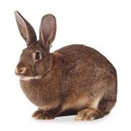 It’s a rabbit.
- What can you see on this picture?
 It’s a goldfish.
- What can you see on this picture?
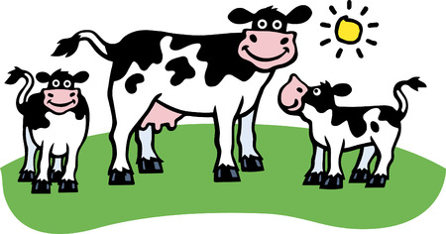 It’s a cow. Where does the cow live? – It lives on the farm.

- What can you see on this picture?
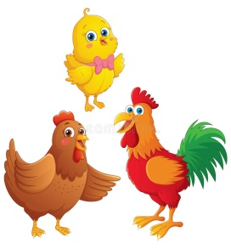 We can see hens. Where do hens live? – They live on the farm.
- What can you see on this picture?
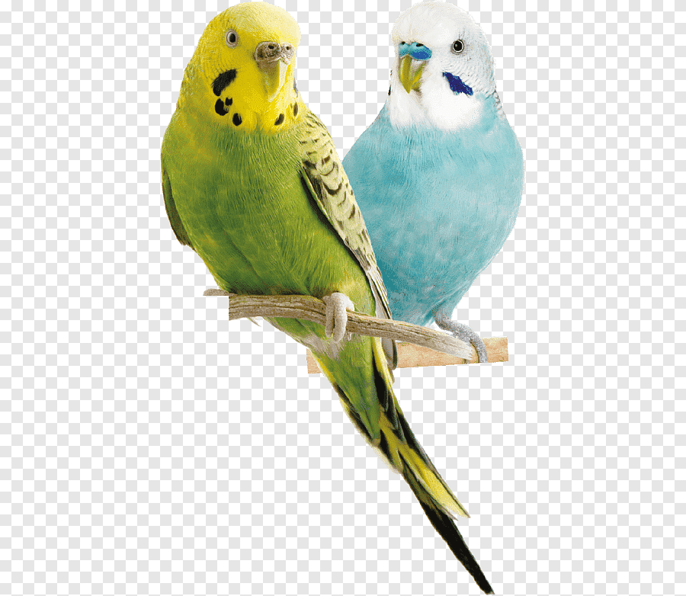 They are budgies. Where do budgies live? – They live in the
house.
- What can you see on this picture?
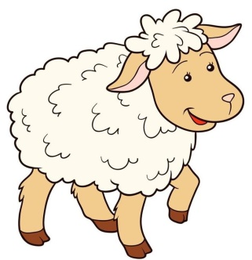 It’s a sheep.
- What are they?
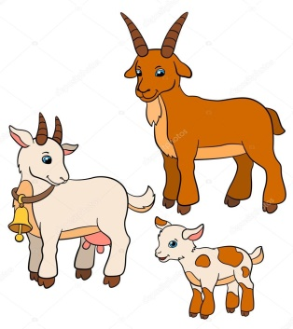 They are goats.
- What can you see on this picture?
 It’s a cat. Have you got a cat at home?
- What can you see on this picture?
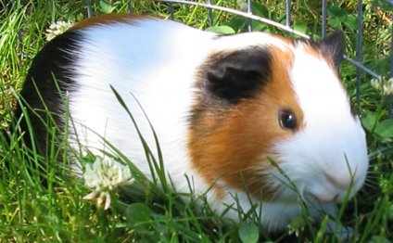 It’s a guinea pig.

- Open you student’s books on page 70, ex.1.
a) Your task is to listen to the sounds and say which animal it is. Are you ready to start? – Ok, now we are ready to start.
b) List the animals under the headings.
PETS | FARM ANIMALS
1. Dog | 1. Duck
2. Goldfish | 2. Goose
3. Cat | 3. Rabbit
4. Guinea pig | 4. Hen
5. Budgie | 5. Cow
6. Tortoise | 6. Goat
 | 7. Sheep

- Thank you so much for your answers!

4) Проведение физкультминутки (Пение композиции Zivert “Green
waves”).

Zivert “Green waves”

***
Where was no sun,
There will be a dawn.
So monotonously.

Where we do not exist,
Green waves.
Beckon to the top,
So far, where an artist.
Paint with the rain.
The strange thoughts
Will be a dream.
If everything is so sipmle,
Why we have to stop?
***
Who said
That friends are forbidden to love?
Watching from a far.
Eyes won't tell anybody
About our route.
Who said
That friends are forbidden to love?
Watching from afar.
Eyes won't tell anybody
About our route.
***
There, where a quiet harbor
Of the forgotten dream.
Will be so close,
But through the glasses.
There's so little meaning,
Where too much love is.
Where was no sun,
There will be a dawn.
So monotonously.
Where we do not exist,
Green waves
Beckon to the top.

***
Who said
That friends are forbidden to love?
Watching from afar.
Eyes won't tell anybody
About our route.
Who said
That friends are forbidden to love?
Watching from a far.
Eyes won't tell anybody
About our route.

5) Основной этап работы по теме урока: Развитие навыков письменной речи (Выполнение заданий по раздаточному материалу: закрепление новой лексики в упражнениях. Работа в парах.
The first task is to write the name of the animal. Use the following words: rabbit, tortoise, chicken, parrot, goat. Then exchange your lists.
For example:
This animal has got a big body and lives on a farm. It can run but it can’t jump.
It is A COW.
- It has got horns (рога) on its head. It is a __________________________ .
- It has got blue feathers (перья). It lives in the house. It is a ________________________ .
- It is a small animal with a round body. It has got a small head. It can’t run.
It is a _____________________________ .
- It has got short fur (шерсть) and long ears. It can’t run. It can only jump.
It is a ____________________________ .
- It has got wings (крылья) and feathers (перья). It lives on farms.
- You have got 2 minutes to do this task.
6) Продолжение по теме урока: Работа по учебнику: Чтение текста “Man’s best friend” (закрепление полученной информации с опорой на “True”/”False”); задание по аудированию.
My dear friends, the second task is to read the text “Man’s best friend!” and translate.
Man’s best friend.
There are many kinds of dogs in the world. They can be big, or they can be small. The St. Bernard is a very big dog with thick fur (толстая шерсть) and thick legs (толстые лапы). The Chihuahua is a very small and has thin (худая), short legs. Dogs love to play, but they can also work. Sheepdogs work on farms and help their owners (хозяины) take care of (заботиться) farms animals like cows and sheep. The Alaskan Husky can pull people in sleds (следы) across the snow. One kind of dog, the German Shepherd, works with the police. Dogs are really great animals. A dog is man’s best friend!

To mark the sentences (T) - (правда) or (F) – неправда.
- There are not many kinds of dogs. F
- The St. Bernard is a small dog. ______
- Chihuahuas have long legs. _______
- Dogs can work on farms. _______
- Sheepdogs help take care of cows. _______
- The Alaskan Husky can pull sleds. _______
- Dogs can’t work with the police. _______
- Children, was it easy to do this exercise or was it difficult to do such exercise?
- It was easy./It was difficult.
- Thanks for your answers!
- And the last third task is to to listen and match the people to their pets.
People | Match the people to their pets | Pets
1. Vicky |  | a) budgie
2. Nathan |  | b) cat
3. George |  | c) goldfish
4. Maggie |  | d) tortoise
5. Susan |  | e) dog
 |  | f) guinea pig
 |  | g) rabbit

- Thanks for your active, my dear friends!!!
8. Этап информации о домашнем задании.
My dear, I’m quite satisfied with your work in the lesson today. I’m pleased with your answers and the work of all of you. Thank you for your active!!! Your mark are “5” and “4”. Your home task for the next lesson will be Ex.5, p.70 (You should write a short message about your pet: the type of the pet; its name; age; description; activities.
9. Этап подведения итогов занятия.
Children, you have got “Hearts” on your desks. If you liked our lesson, please, show the hearts.
I wanna say to you that today our lesson is over, I wish you have a nice day and an excellent mood, goodbye, my dear friends! You may be free!

