Tuesday, the thirtieth of November, 2021.
Form: 4 “L”
The teacher: Жалыбина Елена Геннадьевна

Технологическая карта открытого урока по дисциплине «Английский язык» по теме “Tasty treats. Pirate’s fruit salad”.
Учебно-методическое обеспечение:
УМК “Spotlight 4”:
1) Учебник для 4 класса общеобразовательных организаций, М.: Express
Publishing: Просвещение, 2018. – 184 с.
2) Cборник упражнений. 4 класс: учебное пособие для общеобразовательных
организаций. – М.: Express Publishing: Просвещение, 2021. – 128 с.
Авторы: Н. И.Быкова, Д. Дули, М.Д.Поспелова, В. Эванс.
Тип урока: Урок говорения на английском языке.
Тема урока: “Tasty treats. Pirate’s fruit salad”.
Цели урока:
- Развитие лексико-грамматических навыков;
- Развитие умений аудирования, говорения и чтения и письма.
Задачи урока:
- Ознакомить учащихся с новой лексикой по теме “Food” и закрепить данную
лексику в предложенных заданиях;
- Научить учащихся вести беседу за столом;
- Познакомить учащихся с исчисляемыми и неисчисляемыми
существительными и словами, обозначающими количество.
Активная лексика:
- Lemon, beans, mango, butter, coconut, flour, pineapple, olive oil, sugar, salt and
pepper, tomato. Can you pass me the lemon, please? - Sure! Here you are!; It
looks great. How many/How much?.

Формирование УУД:
Личностные:
- Учебно-познавательный интерес к учебному материалу;
- Формирование и развитие интереса к английскому языку.
Регулятивные:
- Опираться на выделенные учителем ориентиры, сопоставлять выполненную
работу с образцом;
- Адекватно воспринимать и понимать оценки педагога и сверстников.
Коммуникативные:
- Употребление изученных конструкций и лексику в речи в соответствии с
коммуникативной задачей.
Познавательные:
- Использование грамматических структур и понимание условий их употребления в иноязычной речи;
- Овладение навыками поискового чтения.
Методы обучения:
- творческий;
- вербальный;
- наглядный;
- частично-поисковый;
- рефлексия.
Виды учебной деятельности:
-планирование учебного сотрудничества;
- анализ;
- сравнение;
-построение речевого высказывания в устной форме;
-составление высказывания по алгоритму;
- контроль;
- коррекция.

Оборудование:
- УМК Spotlight 4 класс (Учебник, Сборник упражнений);
- Раздаточный материал;
- Картинки с изображением еды;
- ТСО (Экран, проектор, компьютер);
- Мультимейдийные технологии;
- Презентация.
Структура урока:
- Организационный момент;
- Знакомство с темой урока, определение темы и целей урока.
- Этап подготовки учащихся к работе на основном этапе: Введение новой
лексики (Доска+Учебник: Упр.1,2, стр.42);
- Проведение физкультминутки (Выполнение зарядки под музыку D.White “One day”);
- Основной этап работы по теме урока: Развитие навыков письменной речи (Выполнение заданий по раздаточному материалу по лексике «Еда»: “Lemon, beans, mango, butter, coconut, flour, pineapple, olive oil, sugar, salt and pepper, tomato; по устойчивым выражениям “Can you pass me the lemon, please?”, “Sure. Here you are!”, “How many/How much? ”.);
- Работа в парах;
- Проведение физкультминутки (Песенка “What’s in the classroom?”);
- Продолжение по теме урока: Работа по учебнику (Упр.3,4, стр.43);
Восприятие диалога на слух; Чтение диалога с полным пониманием
содержания, умение правильно ответить на заданные вопросы + поисковое
чтение;
- Этап информации о домашнем задании;
- Этап подведения итогов занятия.

Ход урока:
1. Организационный этап.
- Good morning, my dear children and our guests! Welcome to our English lesson! I’m very glad to see you! Today we are having some guests at our lesson. Please don’t feel nervous and try to show all your skills.
- Let’s start our lesson. As usually at the beginning of our lesson tell me “Who is present / Who is absent today?”.
- “Who is on duty today?”.
- Let’s speak about today date. Who can tell me “What date is it today?”, “What day of the week is it today?”, “What season is it now?”.
- And now I’m interested in today weather. I wanna you to try to describe today weather. In your opinion “Is it cold or cool today?”, “Is it a frosty day today?”, “Is it rainy today?”, “What can you say about the days and the nights in autumn?” (In autumn the days become shorter, the nights become longer).
- Thanks for your answers!
2. Знакомство с темой урока, определение темы и целей урока.
- My dear friends, do you remember these funny toys? This is Mr.Carrot; This is
Mr.Banana and this is Miss Pineapple. They are our tourists from England! And
they want to go to the greengrocer’s and to buy smth.. Look at this part of the
blackboard. There’re some pictures in front of you. What can you see on them?
- Who can guess what we’ll talk about today?
- So today you’ll learn, read and talk about food.
3. Этап подготовки учащихся к работе на основном этапе: Введение новой лексики (Учебник: Упр.1,2, стр.42).
- As you know there are a lot of food in the world which people like/dislike. Open you student’s books on page 42, ex.1. Your task is to listen and repeat. And now, my dear friends, look at this part of the board and look at these pictures. The next task for you is to try to repeat after me, please. Are you ready to start?

- What can you see on this picture?
 It’s a lemon. Do you like lemons? Where do you buy lemons? (We can buy at the supermarket/at the greengrocer’s).
- What can you see on this picture?
 It’s beans. Do you like beans? Where do you buy beans? (We can buy at the supermarket/at the greengrocer’s).
- What can you see on this picture?
It’s a mango. Do you like a mango? Where do you buy a mango ? (We can buy at the supermarket/at the greengrocer’s).
- What can you see on this picture?
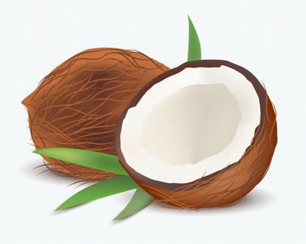It’s a coconut. Do you like a coconut? Where do you buy a coconut? (We can buy at the supermarket/at the greengrocer’s).

- What can you see on this picture?
It’s a pineapple. Do you like a pineapple? Where do you buy a pineapple? (We can buy at the supermarket/at the greengrocer’s).
- What can you see on this picture?
It’s a tomato. Do you like a tomato? Where do you buy a tomato? (We can buy at the supermarket/at the greengrocer’s).
- What can you see on this picture?
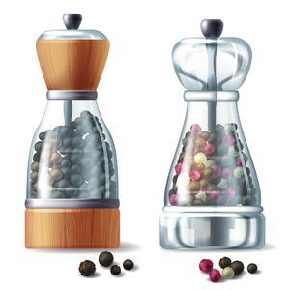It’s some pepper. Where do you buy any pepper? (We can buy at the supermarket/at the greengrocer’s).
- What can you see on this picture?
It’s some salt. Where do you buy some salt? (We can buy at the supermarket/at the greengrocer’s).

- What can you see on this picture?
It’s sugar. Where do you buy some sugar? (We can buy at the supermarket/at the greengrocer’s).
- What can you see on this picture?
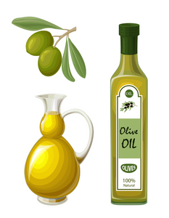It’s olive oil. Where do you buy some olive oil? (We can buy at the supermarket/at the greengrocer’s).
- What can you see on this picture?
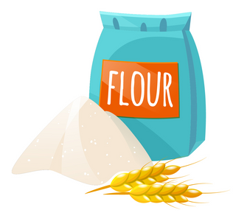It’s flour. Where do you buy some flour? (We can buy at the supermarket/at the greengrocer’s).
- What can you see on this picture?
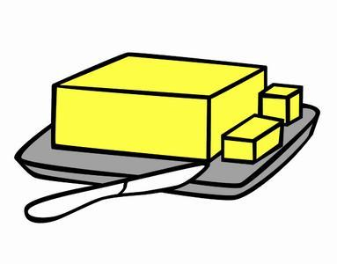It’s butter. Where do you buy some butter? (We can buy at the supermarket/at the greengrocer’s).
- Thank you so much for your answers!

- Let’s complete mini-dialogues as in the example:
The first pupil: Can you pass me the lemon, please?
The second pupil: Sure. Here you are!

The first pupil: Can you pass me the pineapple, please?
The second pupil: Sure. Here you are!

The first pupil: Can you pass me the tomato, please?
The second pupil: Sure. Here you are!

4. Проведение физкультминутки (Выполнение зарядки под музыку).
Boys and girls, it’s time to have a bit rest! Stand up and let’s do some physical exercises, please. You should do like your teacher.
Детишки повторяют движения за учителем под музыку.
D.White “One day”
*****
One day I stop the time
Then look around and smile
And realize there’s everything,
But I am in exile.
On people walking by
I never could rely
The only way is going home -
My cradle under sky
*****
Why is it so difficult to see you here again?
Why is it so typical to ask about your day?
Why are you so magical I’ve never seen before?
Why am I illogical knocking at your door?
*****
My “Magic Land of Oz”
Is not the way it was
“Ant hills” and cars and no stars
The locks on all the doors
I wish we have somewhere
A wizard from the air
Rewind the time when you were mine
Entire world was here
- Did you like these physical exercises? Please, sit down. Continue to work.
5. Основной этап работы по теме урока: Развитие навыков письменной
речи (Выполнение заданий по раздаточному материалу по лексике
«Еда»: “Lemon, beans, mango, butter, coconut, flour, pineapple, olive oil,
sugar, salt and pepper, tomato; по устойчивым выражениям “Can you
pass me the lemon, please?”, “Sure. Here you are!”, “How many/How
much? ”). Работа в парах.
And now, children, I will give cards. Your first task is to read these words, find their meanings and translate from English into Russian, and exchange your lists.
Names of food | Fill in the gaps | Translation
1. lemon |  | a) ананас
2. beans |  | b) оливковое масло
3. mango |  | c) сахар
4. butter |  | d) горох, бобы
5. coconut |  | e) лимон
6. flour |  | f) сливочное масло
7. pineapple |  | g) кокос
8. olive oil |  | h) перец
9. sugar |  | i) помидор
10. salt |  | j) мука
11. pepper |  | k) манго
12. tomato |  | l) соль

- Have you got any questions? – You’ve got 2 minutes to do this task.
The second task is to choose the right form of the verb “to be”: is or are.
1. There ________ some olive oil in the salad.
2. There ________ a lot of potatoes in the box.
3. There ________ some sugar in the tea.
4. There ________ a lot of butter in the fridge.
5. There ________ a lot of tomatoes in the salad.
6. There ________ some flour in the bag.
- You’ve got 2 minutes to do this exercise.
- Who wants to answer? – Ok, let’s start one by one.
The third task to you is to look at this part of the blackboard, read words and write them down in alphabetical order.
Mango, lemon, coconut, sugar, pepper, beans, tomato, salt, butter, flour, pineapple, olive oil.
1. 7.
2. 8.
3. 9.
4. 10.
5. 11.
6. 12.

And the last task for you to choose the right word and circle it.
A. There isn’t ____________ milk in the glass.
1) a lot 2) much 3) many
B. There are _____________ oranges in the fridge.
1) much 2) many 3) a lot of
C. Is there any butter? – Yes, but not ____________ .
1) much 2) any 3) many
D. How ____________ bread is there?
1) many 2) much 3) a lot of
E. Are there any beans? – Yes, but not ___________ .
1) much 2) any 3) many
- Thanks for your active, my dear friends!!!
6. Проведение физкультминутки (Песенка “What’s in the classroom?”);
The song “What’s in the classroom?”
*****
What’s in the classroom?
Let’s have a look!
Posters and pictures,
And work in a book.
*****
What’s in the classroom?
What can you see?
Drawers and a cupboard
For you and for me.
*****
What’s in the classroom?
What’s over there?
A door and a window,
A table and chair.
*****
What’s in the classroom?
What can you see?
A board and pegs
For you and for me.
7. Продолжение по теме урока: Работа по учебнику (Упр.3,4, стр.43)
My dear, open your student’s books on page 27, Ex.3.
Now you’re listening to this dialogues twice. You task is to listen to it very carefully and then read this dialogues. Is it clear? Let’s start.
Here are some new words:
Can you pass me the lemon, please? – Не могли бы Вы передать мне лимон,
пожалуйста.
Sure! Here you are! – Конечно! Вот, возьми!
It’s your turn. – Теперь Ваша очередь.
Make sure you put a lot of sugar in it. – Убедись, что добавил много сахара в него.
- You have just listened to this dialogues, read and now I want you to answer some questions.
1) Who are the main characters? (Lary, Paco, Lulu).
2) Where does the place take? (The place takes in the kitchen).
3) What are children cooking? (They’re cooking a Pirates’s fruit salad).
4) What’s wrong with Larry’s salad? (There isn’t any sugar in it, but there’s a lot of salt).
- Thanks. I think it’s enough.
8. Этап информации о домашнем задании.
My dear, I’m quite satisfied with your work in the lesson today. I’m pleased with your answers and the work of all of you. Thank you for your active!!! Your mark are “5” and “4”. Your home task for the next lesson will be to make your own salad and draw a picture of your salad and then you’ll tell us what you need for eat.
9. Этап подведения итогов занятия.
Children, you have got “Hearts” on your desks. If you liked our lesson, please, show the hearts.
I wanna say to you that today our lesson is over, I wish you have a nice day and an excellent mood, goodbye, my dear friends! You may be free!

